Kingdom of fates

There are the following type of cards:

Champions – Beast, Templar, Wizzard, Warrior, Allies.

Kingdoms

Fate Cards

Wizzard Spells

Templar Spells

Magical Items

Artifacts

Every card has an element associated with it (if not given it has no element).

Champions are the monster cards of the game. They are placed either in attack positions, defence position or face down defence position. Attack position is placed vertically, while defence position is placed horozontally.

Kingdom provides additional effects to the field. They work in the following way. Each player can have 1 kingdom on the field at a time. The effect of the kingdom will come into effect on the attacking phase. The player who is defending will have the advantage that his kingdom’s effect will run. The attacker’s kingdom effect will not be activated. All kingdoms are placed horozontally.

Fate cards are quick play cards. They are set up in your turn and played at any time during the game once they are set up. Fate cards are placed face down, unless the effect is active or activated.

Wizzard Spells are spells that can be cast wich alter the rules of the game. A wizzard must be on your side of the field in order to activate this card.

Templar Spells – See wizzard spells, except for the fact that a templar is needed on the field in order to activate this card.

Magical items are equiped on another champion to give him special effects. A champion can have any amount of magical items equiped on him unless otherwise stated.

Artifacts are exactly like magical items, except their element needs to correspond with the monster. Only one artifact can be equiped to a champion during the game.

Each card should be rendered as follows:

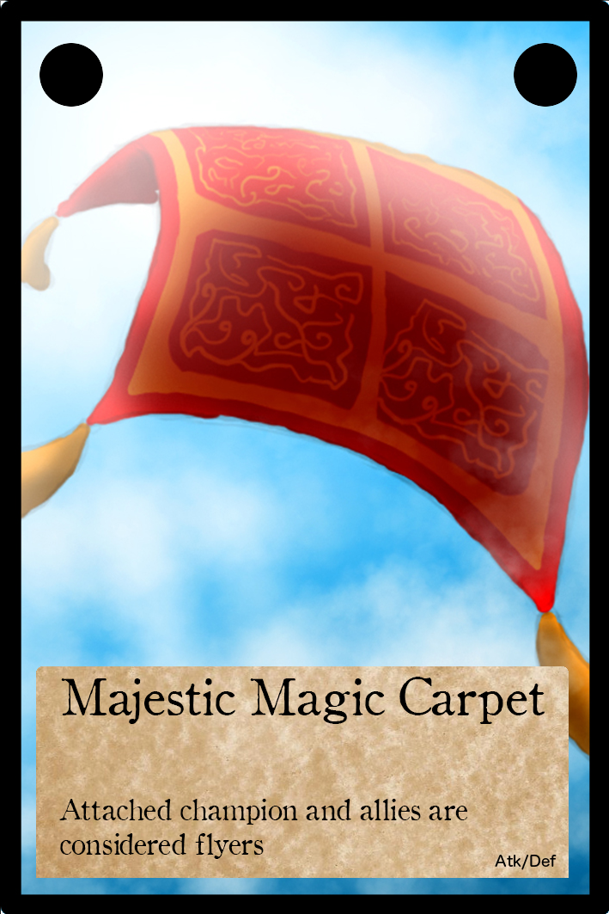

With the name as shown, description underneath and the attack and defence at the bottom right of the corner. The element of the card (if present) should be displayed in the top right and corner and the card type in the top left hand corner as shown.